Chennai-602105


SIMATS ENGINEERING
Saveetha Institute of Medical and Technical Sciences
Chennai-602105

CSA0311-DATA STRUCTURES
CO1-ASSESMENT TOOL
OUTPUT PREDICTION

NAME:AKILESHWARAN A
REG NO:192511354
COURSE:Data structures
COURSE CODE:CSA0311
DATE OF SUBMISSION:24/07/2026

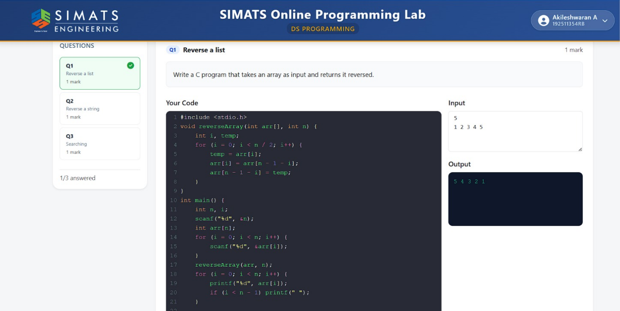
Q1. REVERSE A LIST .

Q2.REVERSE A STRING
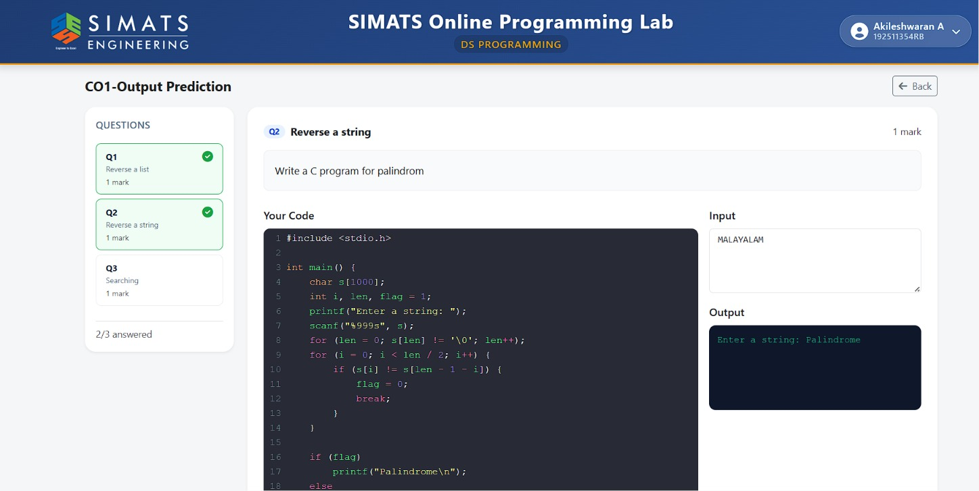

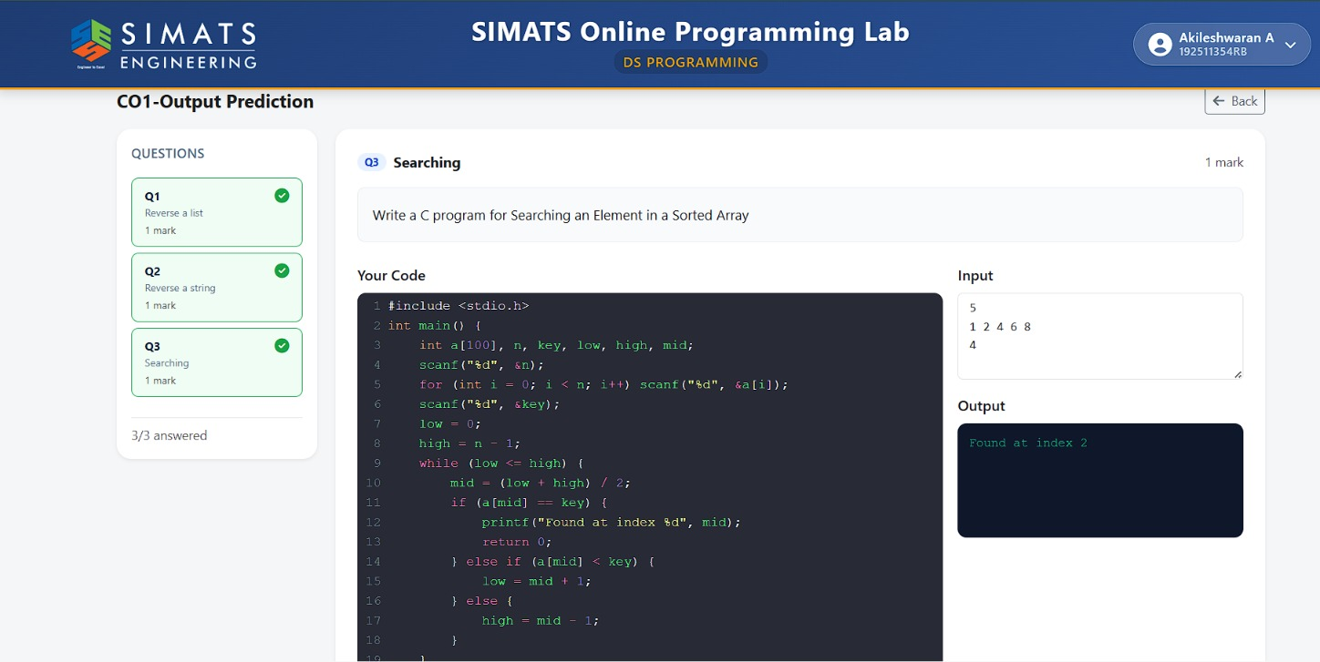
Q3.SEARCHING

